**Pizza Sales Report**

**KPI**

**A. Total Revenue**

select sum(total_price) / count(DISTINCT order_id) as Avg_order_value from pizza_sales;

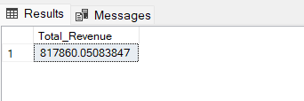**Average order Value:**

select sum(total_price) / count(DISTINCT order_id) as Avg_order_value from pizza_sales;

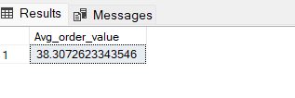**Total pizza sold**

select sum(quantity) as Total_pizza_sold from pizza_sales;

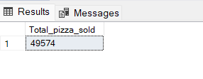**Total orders**

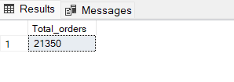select count(distinct order_id) as Total_orders from pizza_sales;

**Avg.pizzas per order:**

select cast(cast(sum(quantity) as Decimal(10,2)) / cast(count(Distinct order_id) as decimal(10,2)) as decimal(10,2)) as Avg_pizza_per_order from pizza_sales;

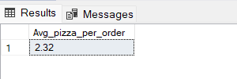

**B. Daily Trend for total orders:**

select DATENAME(month, order_date) as Month_name, COUNT(distinct order_id) as Total_orders

from pizza_sales

group by DATENAME(month, order_date)

order by total_orders desc;

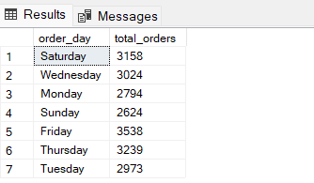

**C. Hourly Trend for Orders:**

select datepart(hour, order_time) as order_hours, count(distinct order_id) as total_orders

from pizza_sales

group by datepart(hour, order_time)

order by datepart(hour, order_time)

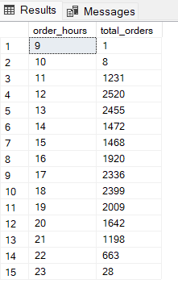

**D. % of sales by pizza category**

select pizza_category, cast(sum(total_price) as decimal(10,2)) as total_revenue,

cast(sum(total_price) * 100 / (select sum(total_price) from pizza_sales) as decimal(10,2)) as PCT

from pizza_sales

group by pizza_category;

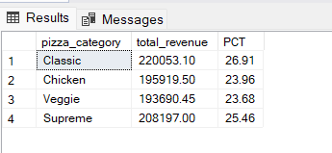

**E. % of sales by pizza catgory**

select pizza_size, cast(sum(total_price) as decimal(10,2)) as total_revenue,

cast(sum(total_price) * 100 / (select sum(total_price) from pizza_sales) as decimal(10,2)) as PCT

from pizza_sales

group by pizza_size

order by pizza_size;

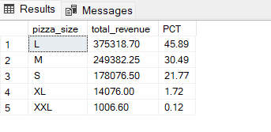

**F. Total Pizza sold by pizza category**

select pizza_category, sum(quantity) as total_quantity_sold

from pizza_sales

where month(order_date) = 2

group by pizza_category

order by total_quantity_sold desc;

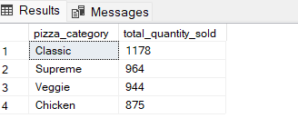

**Daily Trend for total orders:**

select pizza_category, sum(total_price) * 100 / (select sum(total_price) from pizza_sales) as total_sales

from pizza_sales

group by pizza_category;

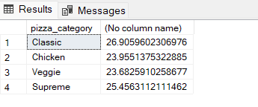

**Percentage of sales by Pizza size: (Quarter Month)**

select pizza_size, cast(sum(total_price) as decimal(10,2)) as total_sales, cast(sum(total_price) * 100 /

(select sum(total_price) from pizza_sales where datepart(quarter, order_date)=1) as decimal(10,2)) as PCT

from pizza_sales

where datepart(quarter, order_date)=1

group by pizza_size

order by PCT DESC;

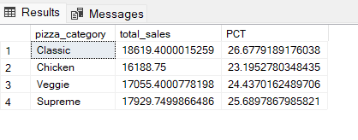

**Total Pizza sold by Pisa category:**

select pizza_category, sum(total_price) as total_sales, sum(total_price) * 100 / (select sum(total_price) from pizza_sales

where month(order_date) = 1) as PCT

from pizza_sales

where month(order_date) = 1

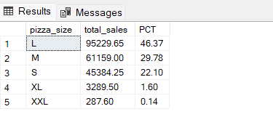group by pizza_category;

**Top 5 best sellers by revenue total quantity and Total orders:**

select top 5 pizza_name, sum(total_price) as total_revenue from pizza_sales

group by pizza_name

order by total_revenue desc;

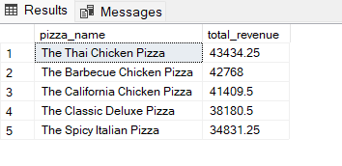

**Bottom 5 best sellers by revenue total quantity and Total orders:**

select top 5 pizza_name, sum(total_price) as total_revenue from pizza_sales

group by pizza_name

order by total_revenue asc;

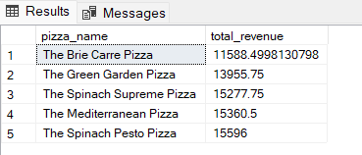

**Bottom level Top 5 best sale quantity**

select top 5 pizza_name, sum(quantity) as total_quantity from pizza_sales

group by pizza_name

order by total_quantity asc;

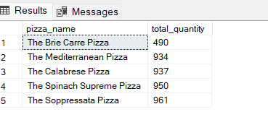**Top Level top 5 best sale quantity**

select top 5 pizza_name, sum(quantity) as total_quantity from pizza_sales

group by pizza_name

order by total_quantity desc;

